Abstract— Our Device “Cognitive Apprehensive Device” is a device that can be worn and can be used for security purpose. This device is being formulated for the society, especially for the safety of women, which is a major concern in today’s life. This fact has motivated us to contribute towards the field of safety. Although there exist several devices in the market pertaining to safety they haven’t produced the desired results because of their inability to function effectively during critical situations. The main problem concerning these existing devices is that they require the user’s interaction with device to get activated which is very difficult in a real life scenario. Our device on the other hand is an innovative device that you don’t need to press or squeeze to activate when the user is in danger. This device connects to a BLE enabled smartphone directly. This device contains a tri-axes accelerometer which is governed by an Arm-Cortex Mo+ microprocessor. The accelerometer detects a motion (push, pull or tug) and sends these readings to the microprocessor. The microprocessor contains an algorithm which compares this motion with a predetermined threshold value, there by activating the device.
Cognitive Apprehensive Device
Prerna Bajaj(1BM12CS082), Student, BMSCE, Raksha Desai(1BM12CS088), Student, BMSCE, Pronoy Dalal(1BM12CS079), Student, BMSCE, and Vardaan Tyagi(1BM12CS138), Student, BMSCE

Index Terms—Accelerometer, Arm Cortex Mo+ Nordic 51288, Bluetooth low energy, Wearable security device

Introduction
J ewelry has been an integral and almost essential part of all cultures—prehistoric to contemporary period. Jewelry with special powers is also part of folklore and mythology. That the modern technology can indeed endow jewelry with special abilities is the premise for this project. Today with advances in affordable miniaturization technologies and societal acceptance of wearable technical gadgets, it is possible to make jewelry that can incorporate sensors, actuators, and wireless communication chips to enhance human experience in daily lives. This is known as Cognitive Jewelry. While you probably feel safe at home with your security system, that feeling of protection may not extend far from your front door. This wearable device has a technology that can help offer you that sense of security no matter where you are. This device is being formulated for the society, especially for the safety of women, which is a major concern in today’s life. The device is used to provide flexibility and choices for the wearer.

Related Work
Until today many devices exist which were made to ensure the safety of any individual, like, for example, as stated by Nudnik and Lorgia[1], the European based project named Preotex, which used the integration of wearable sensors in garments. BLE consumes less power as compared to the classic Bluetooth. Our device incorporates optimal use of various modules such as a Bluetooth Low Energy, an Accelerometer, and an handheld device. Each of these modules, serve a different yet pre-defined task which decide the overall functionality of the device. We will look at the different areas where these modules work one by one. As stated by Stephen Brewster [2], Mobile and wearable computers present input/output problems due to lack of interaction techniques. The deals with generating new ways to interact with the day-to-day usable wearable devices. The article gives the major inspiration for introduction of gesture recognition design in the model.
Our major component used here is the microprocessor ARM Cortex Mo. Additional information can be gained on the webpage [3]. The webpage gives a brief description of the Radio Frequency Identification (RFID) System-on-Chip (SoC). It describes the architectural features of the chip. The chip incorporates a 32-bit ARM Cortex M0 CPU which is highly capable of being flexible with much needed application performance. It is also important to program these algorithms correctly. The webpage [4] shows about the software development around a Nordic semiconductor environment. It shows the usage of nRF51 series versatile single board development kit by nRF51 DK and nRF51 dongle.
Now coming onto our next component, Bluetooth. Our research on various papers related to Bluetooth Low Energy (BLE) indicates that BLE is a better choice than Classic Bluetooth for several reasons.The paper presented by Akhilesh G. Naik Microelectronics, ETC Dept., Goa College of Engineering, Goa University, India[6] explains SPP (Serial Port Profile) application for Classic Bluetooth and SPPLE for BLE, their configuration and functionality will help evaluate the Classic Bluetooth and BLE technology that can be used to connect devices wirelessly in an industrial setting.The paper titled – Development of Wireless Sensor Networks using Bluetooth Low Energy (BLE) For Construction Noise Monitoring [8] illustrates Bluetooth low energy (BLE) for the development of Wireless sensor networks (WSNs) for noise identification and sound locating. It employs networking protocols that uses raspberry pi as a gateway in the network. This paper on Wireless Connectivity for Medical Monitoring [9][10] focuses on the widespread adoption of wireless technologies on medical applications which requires leveraging data transmission by using Bluetooth Low Energy (BLE) which link wireless sensors via radio frequencies to cell phones and computers. The data obtained can be analyzed that can help physicians manage diseases better.

Our device also uses the 3-axial accelerometer instead of face recognition methods and geared for an individual rather than an environment. Next we researched a similar paper titled- Emergency Application for Women [14] [20] which depicts an alert system for PROB detection using commercially available electronic devices to both detect the PROB and alert authorities. We use an Android based smart phone with an integrated tri-axial accelerometer. Data from the accelerometer is evaluated with several thresholds based algorithms. Another paper [17] recognizes the use of an accelerometer, present inside every cellphone, to predict the activity (walking, climbing, sitting) of the owner. To implement this system labeled accelerometer data was collected from 29 users and then aggregated to predict the activity. The usage of a 3-axis accelerometer to measure the acceleration in all the three dimensions prompted us to take it up as one of our major components to help develop the system.

Design

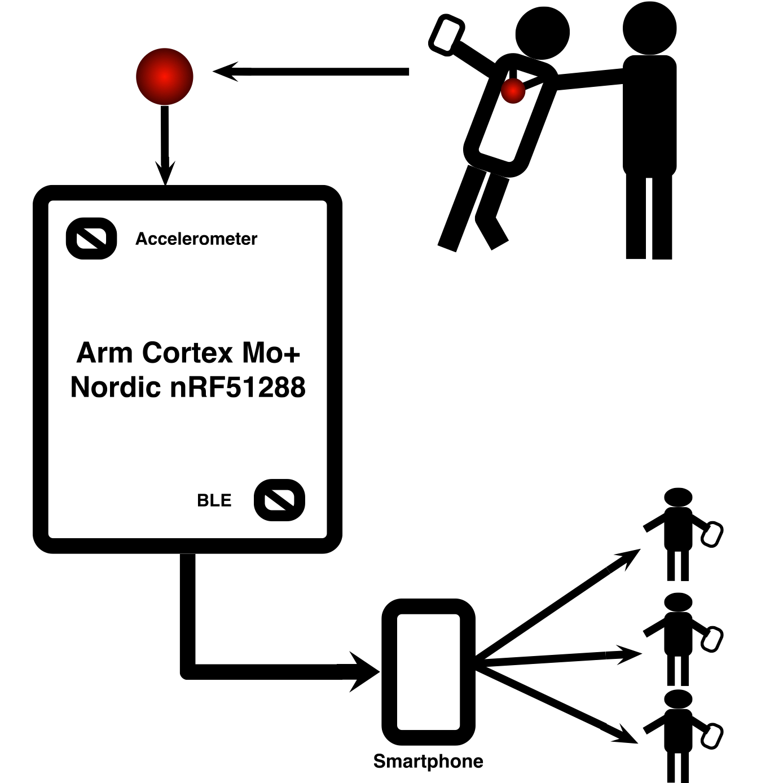

Fig. 1. A high level design showcasing the workflow in the model.

A high level design can be showcased from FIG 1. The system incorporates the combined working of a 3-axis Accelerometer and a BLE device, placed on the ARM Cortex Mo+ Nordic nRF51822 microprocessor. The accelerometer detects a high level, motion based gesture recognition as an assault and logs the data accordingly. This data is sent to the microprocessor to carry out further calculations. In this case, the microprocessor judges the frequency of the motion and compares it to a predefined threshold frequency. If the detected frequency is greater than the threshold value, then the gesture is determined to be a probable attack on the bearer. The microprocessor then, signals the BLE device to generate a connection with the bearer’s handheld smart device. The BLE device would then signal the smart device to carry out further appropriate actions. The smart device understands the signal and immediately transmits SOS messages to other individuals. These contacts of these individuals are predefined and already fed to the smart device to be addressed in an emergency situation.
The microprocessor is embedded with an algorithm written in simple C Language. This encoding can be done through Keil C166 Software Development Kits(SDKs). To implement the working of BLE, smart Bluetooth stack protocol modules are used. The Nordic nRF51288 comes with a library for such predefined stack modules. On the user side, the handheld smart device can be incorporated with an Application written on Eclipse platform.
A systematic workflow model is showcased below in Fig 2.

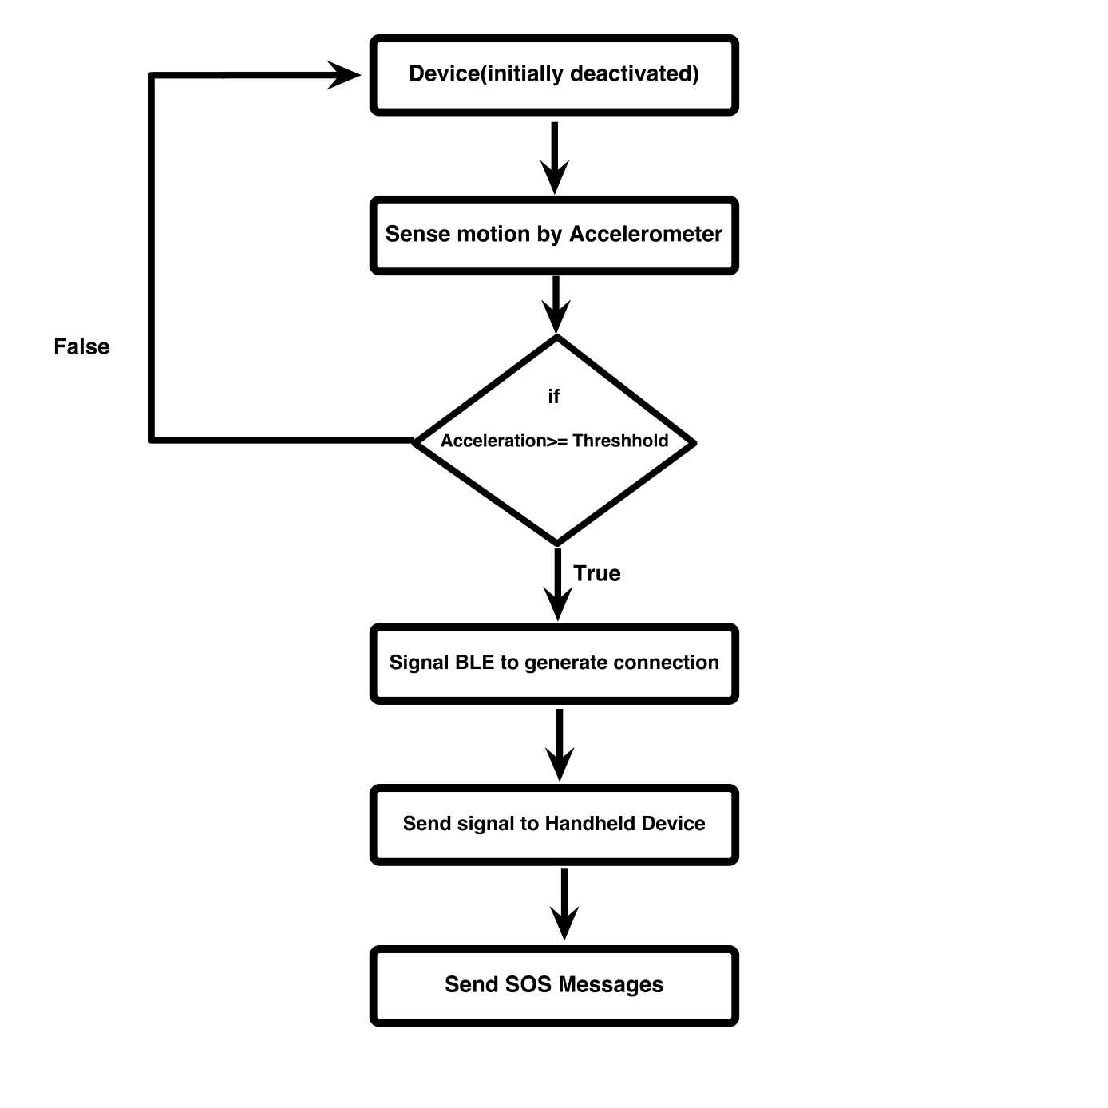

Fig. 2. A Flowchart showcasing the actual working in the model

Requirements

Functional Requirements

Regulatory/ Compliance Requirements
- The accelerometer must define the threshold values to detect an assault.
- The BLE should form a reliable connection with the handheld device.
- The space and time complexity of algorithms must be low to carry out calculations in the nick of a time.

Interface Requirements
- The Handheld device must recognize the messages sent through BLE.
- The Accelerometer and BLE must be coordinated to provide precise data.
- The Microprocessor must calculate the gestures and keep a log of data.

Non Functional Requirements
- Ease of Use- This device must not require any kind of external physical contact such as pressing or squeezing to be activated, any act of physical violence can be automatically detected by embedded sensors and messages are then delivered through your smartphone.
- Size- Since it must fit inside a pendant, the size is diminutive. Being diminutive, the actual purpose of the device is hidden. Hence secrecy would also be maintained.
- Portability- As a device its functionality is accomplished only if worn as a jewelry and this makes it important that the device must be portable which means the device is always attached to the user.
- Robustness- The device must be robust to ensure no damage in case of falling.
- Reliability- This device should guarantee quick activation and ensures that the message must be delivered to the authenticated person.

System Requirements

Hardware Requirements

ARM Cortex MO+ (Nordic 51822)
A microprocessor to log data and to carry out necessary calculations.

3-Axis Accelerometer
A 3-Axis accelerometer for motion based gesture recognition

BLE(Bluetooth Low Energy)
Bluetooth device to generate connection between handheld device and microprocessor.

Handheld Device
A handheld device to maintain connection through Bluetooth

Software Requirements

Keil C166 Development Tools
Platform to develop code for the microprocessor.

32 bit Operating System (Windows/MAC)
Platform to run Keil C166

Bluetooth SDKs
Platform to code for BLE.

Acknowledgment
The authors gratefully acknowledge the contributions of our Computer Science and Engineering Dept., our principal Dr. Malikharjuna Babu and our Prof. Lohith J J for their work on the original version of this document.

References

[1]Stephen Brewster,” Multimodal 'eyes-free' interaction techniques for wearable devices”, 2003
[2]Steve Mann, Jason Nolan and Barry Wellman,” Sousveillance: Inventing and Using Wearable Computing Devices for Data Collection in Surveillance Environments.”,2003
[3]Sabri Khssibi, Hanen Idoudi, Adrien Van Den Bossche, Thierry Val and Leila Azzouz Saidane,” Presentation and analysis of a new technology for low-power wireless sensor network”, May 2009
[4]Josie Hughes, Jize Yan and Kenichi Soga Cambridge University Engineering Department, Trumpington Street, Cambridge, CB2 1PZ, UK,” Development Of Wireless Sensor Network Using Bluetooth Low Energy (BLE) For Construction Noise Monitoring”, June 1, 2015
[5]Akhilesh G. Naik Microelectronics, ETC Dept., Goa College of Engineering, Goa University, India,” Evaluation and Comparison of Classic Bluetooth and Bluetooth Low Energy (BLE) for Industrial Applications” , 3 March 2015
[6]Alf Helge Omre, BTech–EEE, Nordic Semiconductor, Oslo, Norway, “Bluetooth Low Energy: Wireless Connectivity for Medical Monitoring”, March 1, 2010
[7]K.Gautham, G.Raghav, N.R.Raajan, Department of ECE, SEEE, SAST1RA University Thanjavur, Tamil Nadu, India,” Personnel Security System using Bluetooth Low Energy (BLE) Tag”, May 2014
[8]Curone, Nudnik, Loriga and more,” Smart Garments for Safety Improvement of Emergency/Disaster Operators” Aug, 2007
[9]Activity Recognition using Cell Phone Accelerometers Published by: Jennifer R. Kwapisz, Gary M. Weiss, Samuel A. Moore Department of Computer and Information Science, Fordham University.
[10]Premkumar, CibiChakkaravarthi, Keerthana, Ravivarma, Sharmila, One Touch Alarm System For Women’s Safety Using GSM , 01, March 2015, Volume No. 04.
[11]Remya George, Anjaly Cherian.V, Annet Antony, Harsha Sebestian, Mishal Antony, Rosemary Babu.T,” An Intelligent Security System for Violence against Women in Public Places”, April 2014 Volume-3, Issue-4. ISSN: 2249 – 8958 (IJEAT)
[12]Mr.Magesh Kumar, Mr.Raj Kumar, IPROB – “Emergency Application For Women”, March 2014. Volume 4, Issue 3. ISSN: 2250-3153
[13]Che-Chang Yang and Yeh-Liang Hsudoi “A Review of Accelerometry-Based Wearable Motion Detectors for Physical Activity Monitoring”, 2010 Aug 20, 10.3390/s100807772 PMCID: PMC323118
[14]Kumar Kandukuri, A. Amala Jency, R. Anita, K.S. Pavithra, V. Seema, “Android Based Women Safety Application with Blood Pressure, Heart Beat Monitoring and Location Tracking, Emergency Support System”, IJSRD - International Journal for Scientific Research & Development| Vol. 3, Issue 01, 201
[15]Jennifer R. Kwapisz, Gary M. Weiss, Samuel A. Moore, “Activity Recognition using
Cell Phone Accelerometers”, Department of Computer and Information Science Fordham University
[16]Nishant Bhardwaj and Nitish Aggarwal, Design and Development of “Suraksha”-A Women Safety Device, International Journal of Information & Computation Technology. ISSN 0974-2239 Volume 4, Number 8 (2014).
[17] “New Directions in Jewelry”: a Close Look at Emerging Trends & Developments in Jewelry-like Wearable Devices Yulia Silina, Hamed Haddadi Cognitive Science Research Group Queen Mary University of London, UK
[18] Chen KY, Bassett DR., Jr The technology of accelerometry-based activity monitors: Current and future.Med. Sci. Sports. Exerc. 2005;37:490–500.
[19] Mathie MJ, Coster ACF, Lovell NH, Celler BG. Accelerometry: providing an integrated, practical method for long-term, ambulatory monitoring of human movement. Physiol. Meas. 2004;25:1–20.
[20] Morris JRW. Accelerometry—A technique for the measurement of human body movement. J. Biomech.1973;6:729–736
[21] Godfrey A, Conway R, Meagher D, ÓLaighin G. Direct measurement of human movement by accelerometry. Med. Eng. Phys. 2008;30:1364–1386
[22] Karantonis DM, Narayanan MR, Mathie M, Lovell NH, Celler BG. Implementation of a real-time human movement classifier using a triaxial accelerometer for ambulatory monitoring. IEEE. Trans. Inf. Technol. Biomed. 2006;10:156–167.
[23] Sabri Khssibi, Hanen Idoudi, Adrien Van Den Bossche, Thierry Val and Leila Azzouz Saidane, Presentation and analysis of a new technology for low-power wireless sensor network International Journal of Digital Information and Wireless Communications (IJDIWC) 3(1): 81-92,The Society of Digital Information and Wireless Communications, 2013 (ISSN: 2225-658X).
[24] “Introduction to Nordic nRF51822”
URL: “https://www.nordicsemi.com/eng/Products/Bluetooth-Smart.../nRF51822”

[25] “Development Tools for Nordic nRF51822” URL : “https://www.nordicsemi.com/eng/Products/Bluetooth-Smart-Bluetooth-low-energy/nRF51822”

 This work has been supported by Computer Science and Engineering dept. of BMSCE, and done under the guidance of Prof. Lohith J J Prerna Bajaj is with the Department of Computer Science and Engineering, BMS College of Engineering, Bangalore, India (e-mail: prerna93lyka@gmail.com). Raksha Desai is with the Department of Computer Science and Engineering, BMS College of Engineering, Bangalore, India (e-mail: desairaksha@gmail.com). Pronoy Dalal is with the Department of Computer Science and Engineering, BMS College of Engineering, Bangalore, India (e-mail: pronoy.pro@gmail.com). Vardaan Tyagi is with the Department of Computer Science and Engineering, BMS College of Engineering, Bangalore, India (e-mail: vardaan.tygai@gmail.com).

